CAI: ENTREPRENEURSHIP
SCHOOL NAMEꓽ ST. JOHNS S.S WAKITAKA
CLASS ꓽ S.3.
TERM 2.
SUBJECTꓽENTREPRENEURSHIP.
THEMEꓽ BUSINESS MANAGEMENT.
TOPICꓽBOOK KEEPING, SOURCE DOCUMENT.
LEARNING OUTCOMES.
- Appreciate the importance of book keeping and demonstrate the skill of book keeping using spreadsheet.
- Use an accounting records.
- Prepare source documents.
SUBJECT COMPETENCYꓽDemonstrates/applies book keeping skills.
GENERIC SKILLSꓽMathematical computation and ICT proficiency.
LEARNING DOMAINꓽPsychomotor.
AN ENTREPRENEURSHIP CAI.
Ability level | Imitation | Manipulation | Precision | Articulation | Naturalization
Situation/Context/scenario | S.T John S.S Wakitaka employed an accountant as a bursar, unfortunately the man did not know what to do as far as book keeping is concerned. | The school management team held a meeting together with Entrepreneurship learners to audit the books of the accountsoffice. | You listened to what the manager told us in the meeting to do about book keeping and financial records. | The ministry of finance organizes an accounting contest, where entrepreneurship learnersof senior three S.T Johns S.S Wakitaka participated. | The senior three entrepreneurship class of St johns SS Wakitaka are operating a school business club about a bakery, dealing in bakery products amidst other challenges.
Task | Read through the information just as it is. | Tell what book keeping is.  - Clearly show the information that can be kept in the accounts office.  - Identify the appropriate tools that can be used in book keeping and financial recording.  - Use the appropriate tools identified to record the data. | Identify the information to be kept.  1. Identify tools to use while keeping the financial records.  2. Record the information using the tools identified. | - Identifythe kind of information to be kept or recorded.  - Choose the tools to use.  - Use the tools to identify and acquire the data to be recorded. | 1. Identifythe kind of information to be kept or recorded  2. Identify and acquire tools to use in recording data.  3. Use tools identified and acquired to record data.

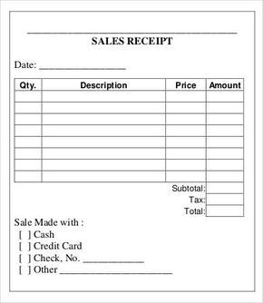
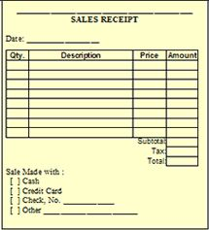
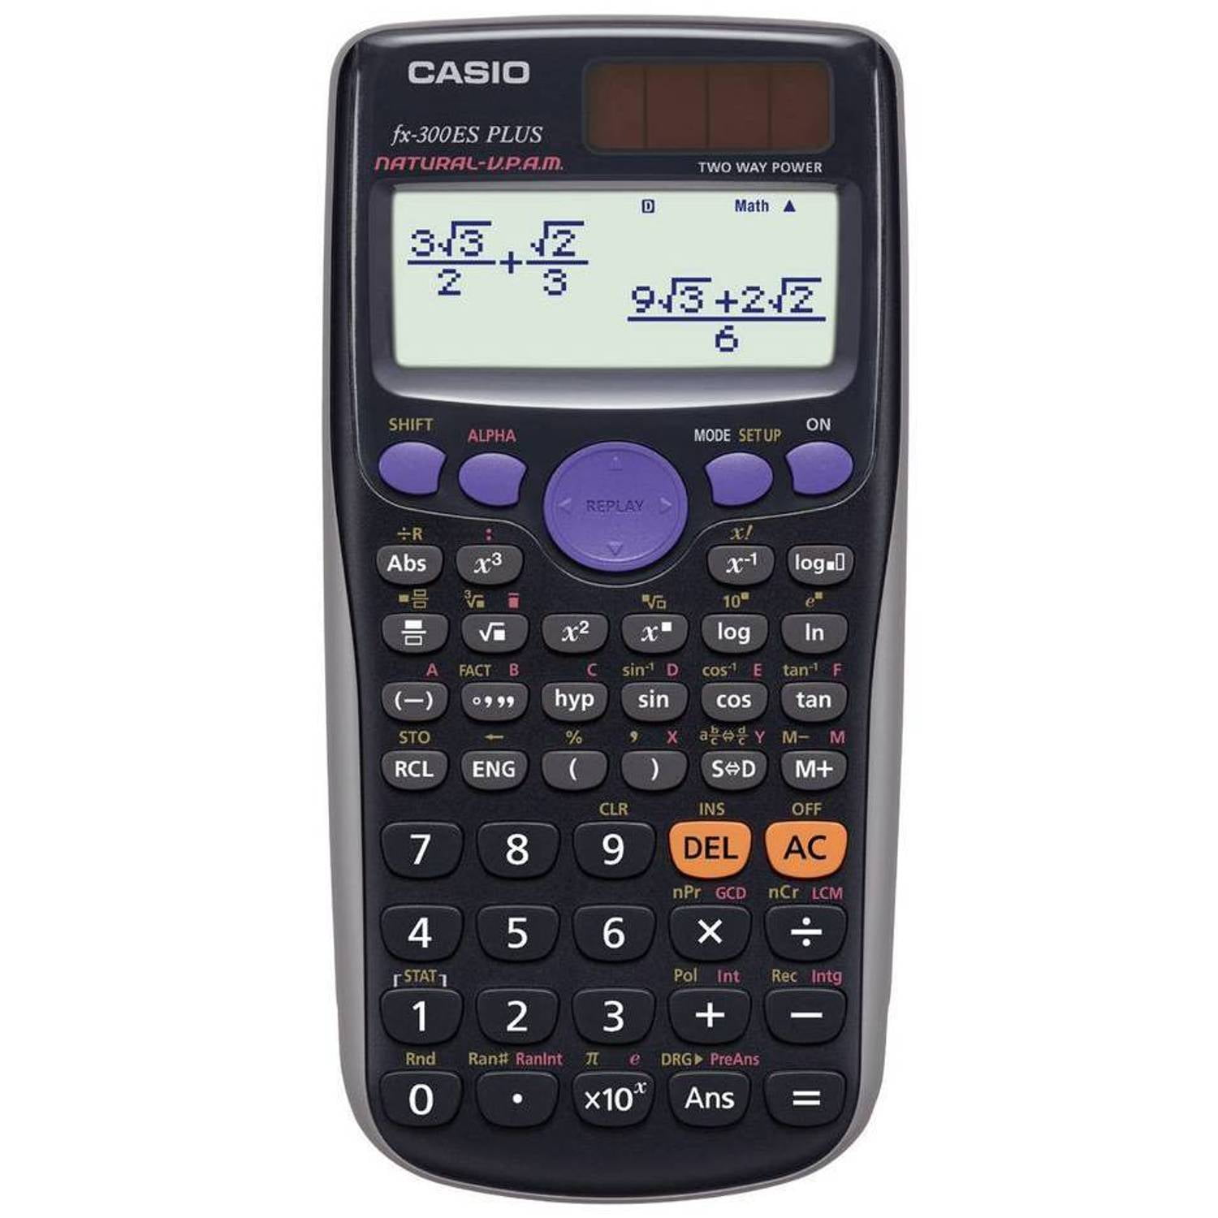
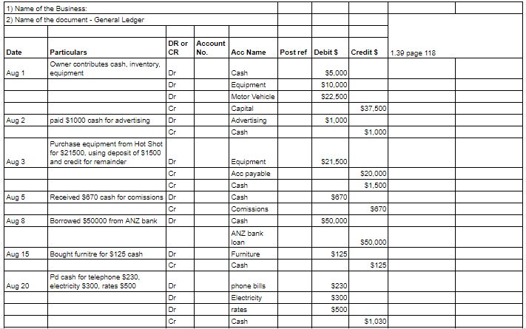
S.T Johs S.S Wakitaka employed an accountant to work as abursarbut unfortunately the man does not know what to do as far as book keeping is concerned.

